TESTING LEFT-Handed TRIAS
Rev 1.1 (20071114 aws)

- Install a TRIA to be tested (left-handed only) onto the WB antenna at TWIB on the roof of PASSCAL. Make SURE that WB Modem is powered down!!!
- Turn on the SM power and verify that data is going to ANF through the SM (Willard – go to TWIB) (Ask Sauter or Busby to check)
- Run TRIA for a period over a month.
- Look at WB history – open IE browser and go to: https://portal2.backoffice.wildblue.net/portal/dt
- Login as 14380 and pwd: hello1
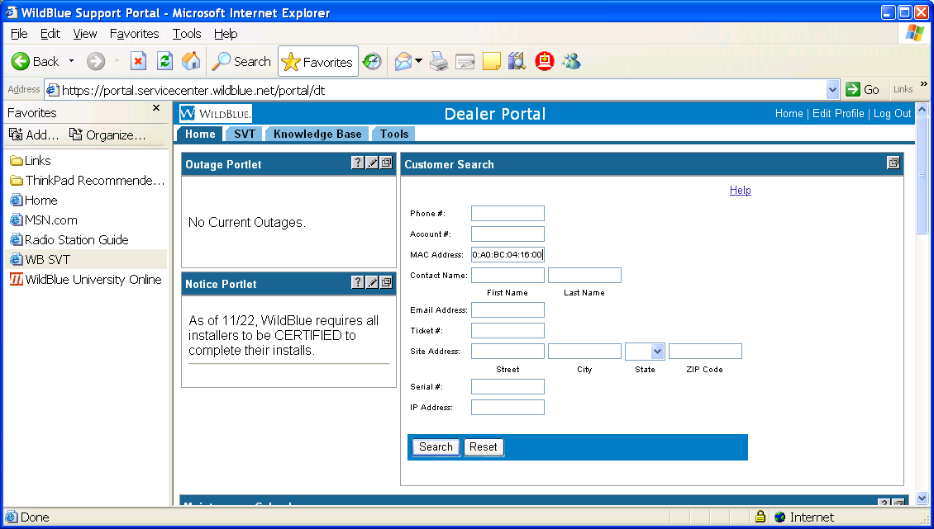
- Enter the TWIB mac address in the MAC address box: 00:A0:BC:04:16:D0 and then click on “Search”. The following info should show up in the right-hand column as shown below:
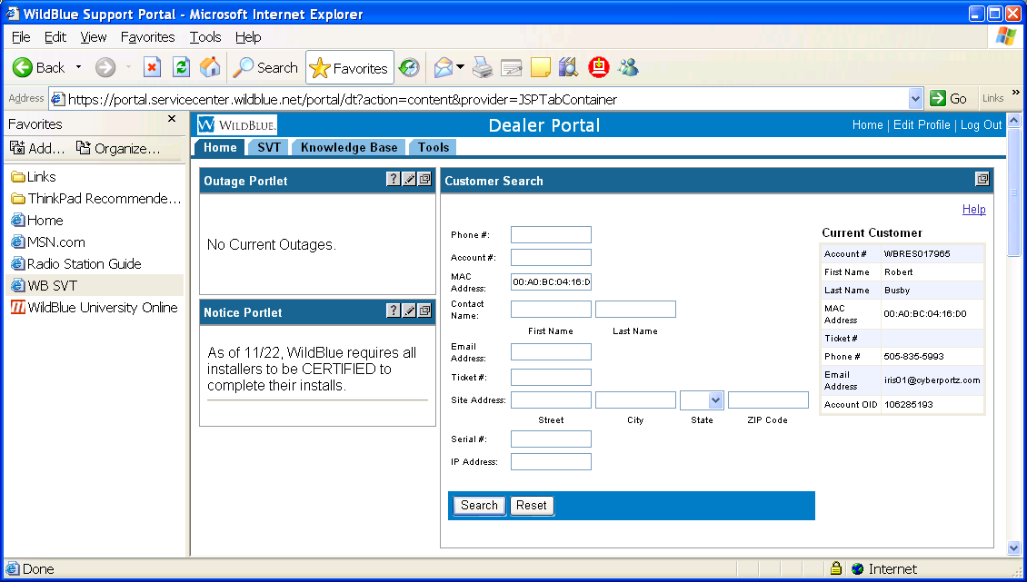
- Click on the SVT tab and the following page will appear (this screen shot shows the bottom of the page, since we next have to click on “Historical Plots”
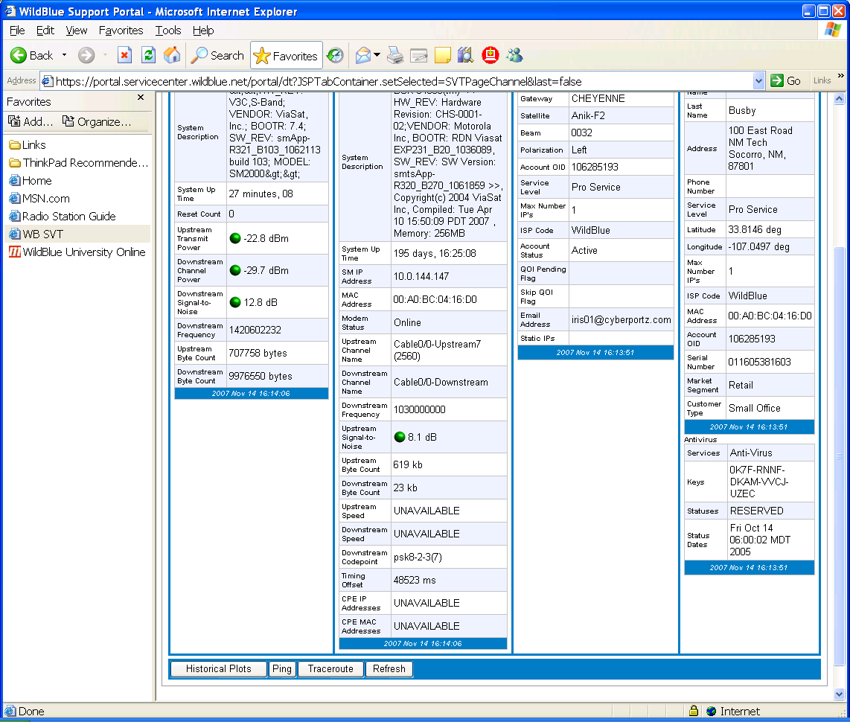
- When it shows up, then enter the date the test started as the starting date: Aug 17 11:23:03 2007 and present time as the end date:
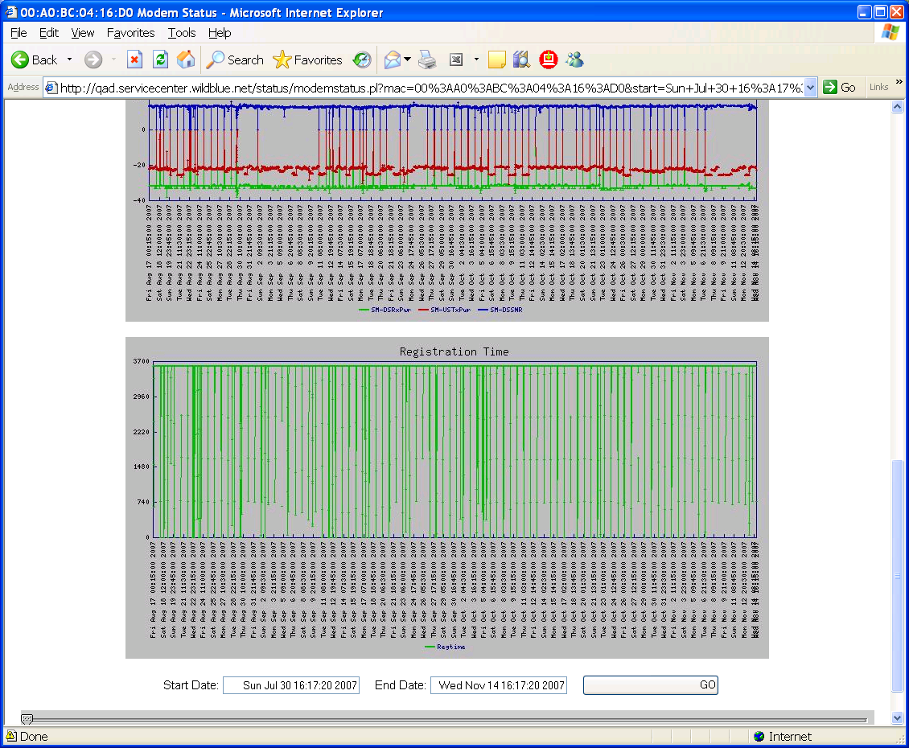

9)This run looks good – daily power cycling only – good connectivity.
10) Put on the next TRIA, make sure it registers, then use Willard to make sure data is going to ANF
11) Start Willard and get Allan to set up Willard to talk to TWIB. Once Willard is set up, do the following:
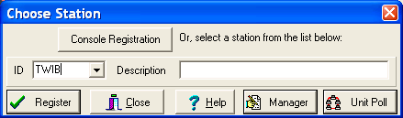
12) Type in TWIB and click on Register. In the window below, type in “0” for the authorization code, and check Save Authorization Code. Then click on “Register”

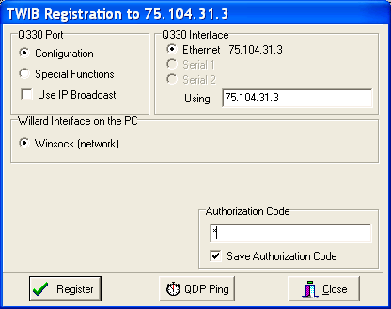

- Make sure Willard communicates w/ ANF:
- 